**Fully Automated Irrigation System**

|  |  |
| --- | --- |
| Aditya A. Desai  Rajarambapu Institude Of Technology Isalampur, | Shreyas R. Patil  Rajarambapu Institude Of Technology Isalampur, |

# ABSTRACT

Our project is a fully automated irrigation system that highlights the optimum solution for the efficient use of water and electricity for agricultural purposes. There are some existing systems who come up with two solutions, one is timer-based and another one is moisture-based atomization. The timer-based system has demerits like being semiautomated i.e., timer needs to be changed manually according to climate. Similarly, in moisture-based systems, reliability is the issue. So the main objectives of the paper are to overcome the demerits of the present systems by integrating both the systems, to develop a fully automated irrigation system, to manage the use of water, electricity, and to add a remote controlling system. The paper includes the integration of moisture and timer-based system which provides the optimum efficiency on the water use and the use of solenoidal valve and siphon technology decreases the use of electricity while our third idea to prepare a smartphone application gives us the advantage to continuous monitoring over the system and provides control over irrigation from anywhere.

Keywords:

Irrigation, Automation, Efficiency, sensors.

# INTRODUCTION

India's ground water levels are critically low and present irrigation systems are poor in efficient water and energy management. So there is definite need of developing the efficient system for irrigation of water. Our project is a fully automated irrigation system that highlights the optimum solution for the efficient use of water and electricity for agricultural purposes. The existing systems come up with two solutions, one is timer-based and another one is moisture-based. The time-based system has demerits like being semiautomated i.e. timer needs to be changed manually according to climate. Similarly, in moisture-based systems, reliability is the issue. So our main objectives are to overcome the demerits of the present systems, to develop a fully automated irrigation system, to manage the use of water, electricity, and to add a remote controlling system. Our idea includes the integration of moisture and timer-based system which provides the optimum efficiency of water and the use of solenoidal valve and siphon technology decreases the use of electricity while our third idea to prepare a smartphone application that gives us the advantage to continuous monitoring over the system and provides control over irrigation from anywhere.

1)Mohamed Ahmed Abdurrahman (2015) Sensor Based Automatic Irrigation Management System: International Journal of Computer and Information Technology (ICIT) In the present review, an attempt has made to make an automatic irrigation system using PIC 16F877A, moisture sensor and induction valve. The sensors are used to measure the moisture level of an soil and control the valve according to the level of moisture.

2) Bishnu Deo Kumar, Prachi Shrivasthay, Reetika Agrawal and Vanya Tiwari (2017) Microcontroller based automatic plant irrigation system: International Research Journal of Engineering and Technology (IRJET):In the present review, an attempt has been made to provide Information about the automated irrigation system using microcontroller (ATMEGA 328). The efforts are made to provide continuous readings of the temperature of atmosphere along with humidity content of soil with an Automated control over irrigation based on ATMEGA 328 and GSM module.

3)Raja. G. Abhiraj. R. Arunkrishnan, Febin Malik. Jesu Jorof Divin. J and Rajarathinum (2018) Smart Polyhouse Farming Using lot Enviroment: International Journal Of Trend in Scientific Research and Development IJTSRV)In this paper some essential sensors, Relay and Power supplies used in (polyhouse are discussed in brief. The sensors which have been discussed are Temperature, Humidity, Moisture and ultrasonic sensors. By implementing automation inside the polyhouse all things are monitoresd through mobile.

4)R.Nageswara Rao,B.Sridhar(2018)IOT Based Crop Filed Monitoring And Automation Irrigation System: second international coferance on inventive system and control(ICISC)This system is used for controlling and monitoring of crop field and this research paper describe the block diagram of IOT based automatic crop field monitoring.

5)G.K.Banerjee,Rahul Singhal(2010)Microcontroller based polyhouse automation controller :International symposium on electronic system design.

In this research paper they discussed that how to control the temperature and relative humidity inside polyhouse using microcontroller.

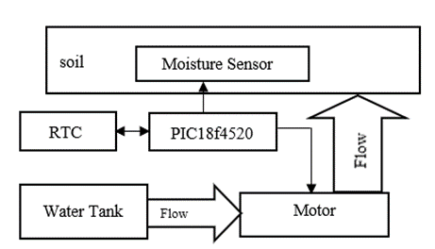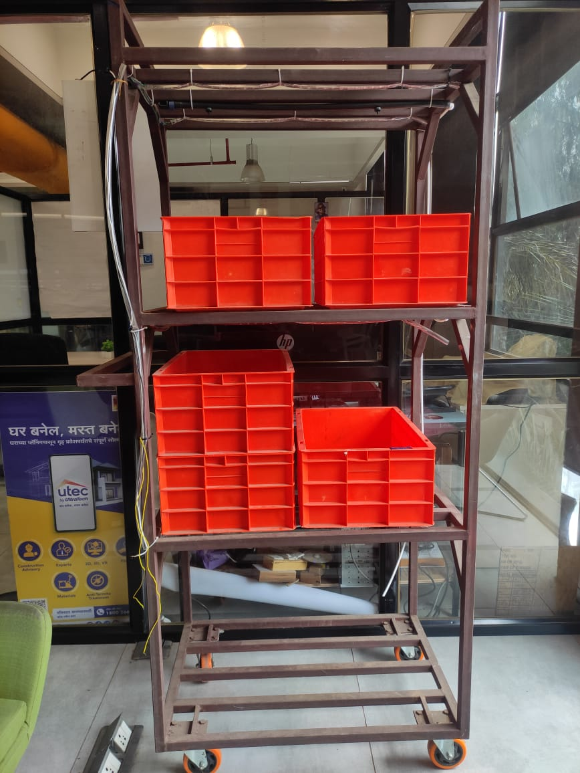BLOCK DIAGRAM

The overall controlling of water is done by following way. The water is stored in upper tank and supplied to each rack independently. Then each rack has its own 12 V motor for individual flow control. Motor is actuated by relay while signal for each really is given by PIC 18f877A microcontroller.

The decision of keeping motor on and off is decided by two factors. One is by the schedule provided by the farmer and the moisture sensor. The main control is provided using schedule but if there is some extreme condition happens and moisture content in soil goes extremely low then moisture sensor can overwrite it and send signal to turn on the motor.

The schedule of watering for particular plant is planned such as it could yield maximum outcome in minimum use of water. To get real-time control over water DS3231 RTC (Real Time Clock) module is integrated with it. Which provides present time and date to the microcontroller and it is compared with planned schedule and when the real time matches with presetted time it gives signal to relay to turn on motor and motor is turned on and water is supplied to the crops. After pre-setted another signal is given to relay indicating turning off of the motor.

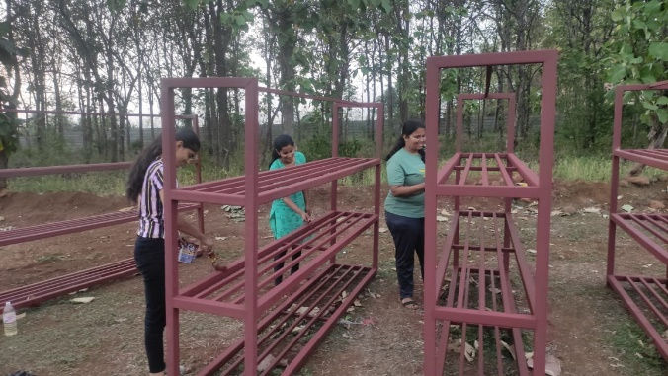During summer due to extreme temperature or by any other means if the moisture content of soil decreases than pre-setted minimum value then it is addressed by the moisture sensor and given to microcontroller now moisture sensor gives immediate instruction to the relay to turn the motor and necessary changes are made in the schedule to keep system running in original state.

Fig. 1 Building the racks for cropping

Fig. 2 Small model of cropping trays in rack

FLOWCHART:

To understand the working of the system we will take some dummy data for watering crops

For 1st week:

The microcontroller does write operation on the RTC module then the continuous time and date are transferred to the microcontroller and value of date and time are copied into Dip=Tip variables. Now if Dip (input date is less than 7 then the loop for week 1 got executed. now if input date and input time are matched with the set date and set time then the motor turned ON. After that proper delay it applicable to keep motor turned on for few minutes after that signal is provided so that motor turns OFF. Then Dset (set date) is increased by 2 days (Dset=Dset) And it again jump to weak condition check unless date is not move than 7 it stay in some loop. Now if the set date and set time are not equal to input date and input time then sufficient then again jumped to week check in condition if it is motor turn off. again Dset is changed to (Dset T1) and jumped weak check condition if date is grater than 7 and less than 15 it enter into second loop.

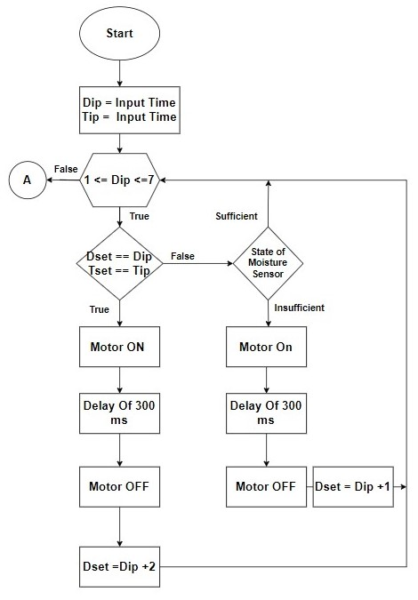

For 2nd week:

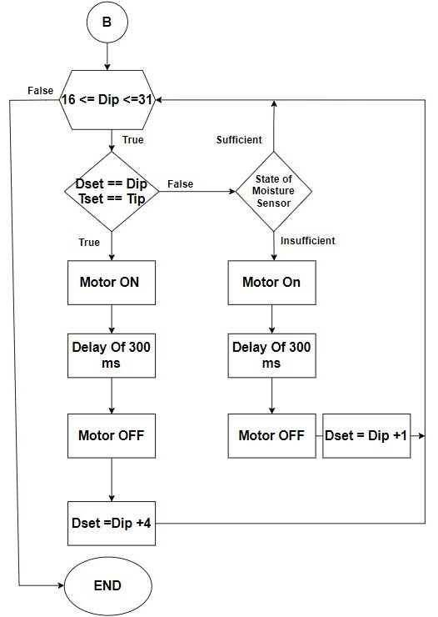

Now if Dip (input date is less than 15)then the loop for week 2 got executed. now if input date and input time are matched with the set date and set time then the motor turned ON. Then proper delay it applicable to keep motor turned on for few minute after that signal is provided so that motor turns OFF. Then Dset (set date)is increased by 3 days(Dset=Dset )And it again jump to weak condition check unless date is not move than 15 it stay in some loop. Now if the set date and set time are not equal to input date and input time then moisture comes into play.it checks the moisture level of soil. if sufficient then again jumped to week check in condition if it is insufficient. then it bypasses timer and turn on the motor. After delay motor turn off. again Dset is changed to (Dset T1) and jumped weak check condition if date is grater than 15 and less than 30 it enter into third loop.

**For 3RD week:**

Now if Dip (input date is less than 30)then the loop for week 3 got executed. now if input date and input time are matched with the set date and set time then the motor turned ON.Then proper delay it applicable to keep motor turned on for few minute after that signal is provided so that motor turns OFF. Then Dset (set date)is increased by 4 days(Dset=Dset t)And it again jump to weak condition check unless date is not move than 30 it stay in some loop. Now if the set date and set time are not equal to input date and input time then moisture comes into play.it checks the moisture level of soil. if sufficient then again jumped to week check in condition if it is insufficient. then it bypasses timer and turn on the motor.after delay motor turn off. again Dset is changed to (Dset T1) and jumped weak check condition if date is grater than 30 .it enter into first loop.

# 

HARDWARE IMPLEMENTATION:

In spite of fruitful study, various control systems were discuss to length. Still there is scope for further improvement and develop controller system to suit the requirements.

There is need of measuring parameters such as moisture content of the soil and real time and date for this perpose the the resistive moisture sensor is used who provides actual water content of the soil while the DS3231 is the RTC module used for taking real time and date.

For the control purpose the PIC18F4520 microcontroller is used which provides industry level reliability and accuracy in the controlling The PIC18F4520 has 32K of program memory, 256 bytes of EEPROM data memory, 1536 bytes of RAM, and 256 bytes of EEPROM data memory, It also has two comparators, a 10-bit A/D converter with 13 channels. Which is appropriate for our use.

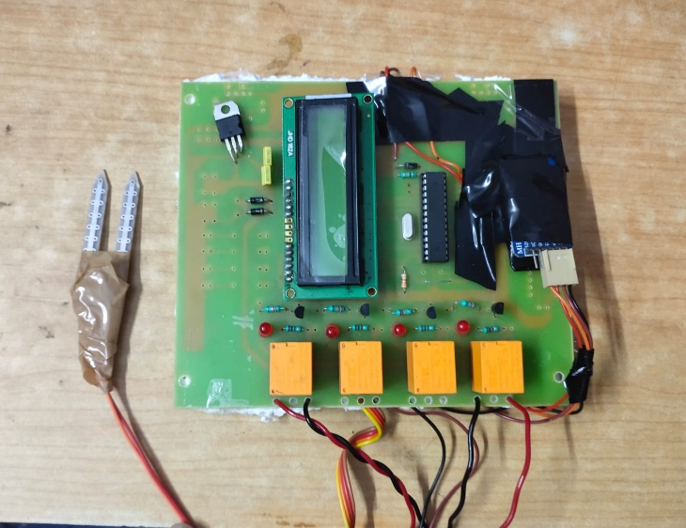For displaying the info 16*2 Lcd is used which continuously displays the information current date and time water state and motor on and of state.

Fig. Hardware model

Results and analysis:

**The power usage :**

Our system :

Electricity used by 1 microcontroller kit 1 Watt per hour

Electricity used by 12 Volt Motor : 60 Watt per hour

Electricity used by 12 Volt Motor: 60+1 = 61 W

For Green House Containing

6 Racks61*6 = 366 W per hour Maximum motor on for 30mins

then total electricity usage in a day : 183 watts

Total usage of the month 183*30 = 5490W

Total Units consumed : 5.490 Units

total running cost of the month : 5.36*5.490 = 29.42 rs

**Conventional System:**

Power consumption by motor : 746 watt per hour

373 watt in each day

Power consumption by motor for month : 373*30

For a month (units) : 373*30 = 11190Whr =11.19 units

cost of running:

223.5*5.36 = 59.97 rs per month

**Water Usage:**

For a Conventional System (half Hp motor)

1960/2 = 980*30 = 29400

1960 litre per hour ;

for a per day 30 mins of use = 1960/2 = 980 litre

for a month 980*30 = 29400 litre

our system

12V 110psi motor = avg 200 ltr per hour

for a per day 30 mins of use = 100 litre per day

for 6 motor 100*6=600 litr per day

600*30 = 18000 liter ;

**Human Efforts :**

In conventional system no matter what you have to put one person for monitoring and control of motor in our case these human are eliminated by incorporating automation for sake of convenience we have considered half hour of human efforts in entire month .

The following graph shows the entire difference in both systems in terms of electricity usage , water usage and human efforts. In all of these aspects our systems comes out as the best. In the case of electricity usage we save around 50 percent of money spend on electricity. The graph also shows the total water usage of the system which is comparatively lot lower than conventional system. We can easily save 40 percent of water by implementing our system. Looking towards human efforts column we can easily say our systems eliminates conventional systems in this case with saving around 90 percent of human efforts.

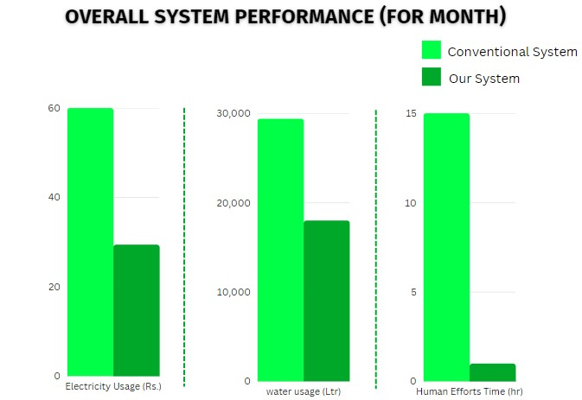

CONCLUSIONS

Temp data needed to be changed

# REFERENCES

/* Dummy

1. J. A. Businger, The glasshouse climate, physics of plant environment, North Publ. Co., Amsterdam, 1963.
2. G. Straten, What can systems and control theory do for agriculture?, in: Proceedings of 2nd IFAC International Conference Agricontrol, Osijek, Croatia, 2007.
3. I. Farkas, Modelling and control in agricultural processes, Comput. Electron. Agric. 49 (8) (2001) 315–316.
4. N. Sigrimis, P. Antsaklis, P. Groumpos, Special issue on control advances in agriculture and the environment, IEEE Control Syst. Mag. 21 (2001) 78–85.
5. N. Sigrimis, R. King, Special issue on advances in greenhouse environment control, Comput. Electron. Agric. 26 (1999) 217–374.
6. T. Burnett, The effect of temperature of an insect hostparasite population, Ecology, (1949) 113–133.
7. K. L. Robb, M. P. Parrella, Towards understanding the thysanoptera, General Technical Report NE147, US (1991) 343–358.
8. F. Rodriguez, Modeling and hierarchical control of greenhouse crop production, PhD thesis, University of Almera, Spain.
9. F. Rodrguez, J. L. Guzmn, Adaptive hierarchical control of greenhouse crop production, Int. J. Adap. Cont. Signal Process 22 (2008) 180–197.
10. N. Wang, N. Zang, Wireless sensors in agriculture industryrecent development and future perspective, Computers and Electronics in Agriculture 50 (2006) 1–14.
11. S. Shanmugantah, A. Ghobakhlou, P. Sallis, Sensor data acquisition for climate change modelling, WSEAS Transactions on Circuits and Systems 7 (2008) 942–958.
12. J. Burrell, T. Brooke, R. Beckwith, Vineyard computing: Sensor networks in agricultural production, Sensor and Actuator Network 7 (2004) 38–45.
13. R. Morais, M. Fernandes, S. M. et. al., A zigbee multipowered wireless acquisition device for remote sensing applications in precision viticulture, Computers and Electronics in Agriculture 62 (2008) 94–106.

*/